**SHANNON FANO CODING**

clc;

clear all;

close all;

m=input('Enter the no. of message ensembles : ');

z=[];

h=0;l=0;

display('Enter the probabilities in descending order');

for i=1:m

fprintf('Ensemble %d\n',i);

p(i)=input('');

end

%Finding each alpha values

a(1)=0;

for j=2:m;

a(j)=a(j-1)+p(j-1);

end

fprintf('\n Alpha Matrix');

display(a);

%Finding each code length

for i=1:m

if(p(i) > 0.02)

n(i)= round(-1*(log2(p(i))));

elseif (p(i) <= 0.02)

n(i) = 5;

elseif (p(i) <= 0.01)

n(i) = 6;

end

end

fprintf('\n Code length matrix');

display(n);

%Computing each code

for i=1:m

int=a(i);

for j=1:n(i)

frac=int*2;

c=floor(frac);

frac=frac-c;

z=[z c];

int=frac;

end

fprintf('Codeword %d',i);

display(z);

z=[];

end

%Computing Avg. Code Length & Entropy

fprintf('Avg. Code Length');

for i=1:m

x=p(i)*n(i);

l=l+x;

x=p(i)*log2(1/p(i));

h=h+x;

end

display(l);

fprintf('Entropy');

display(h);

%Computing Efficiency

fprintf('Efficiency');

display(100*h/l);

fprintf('Redundancy');

display(100-(100*h/l));

OUTPUTS –

**Providing the probability-**

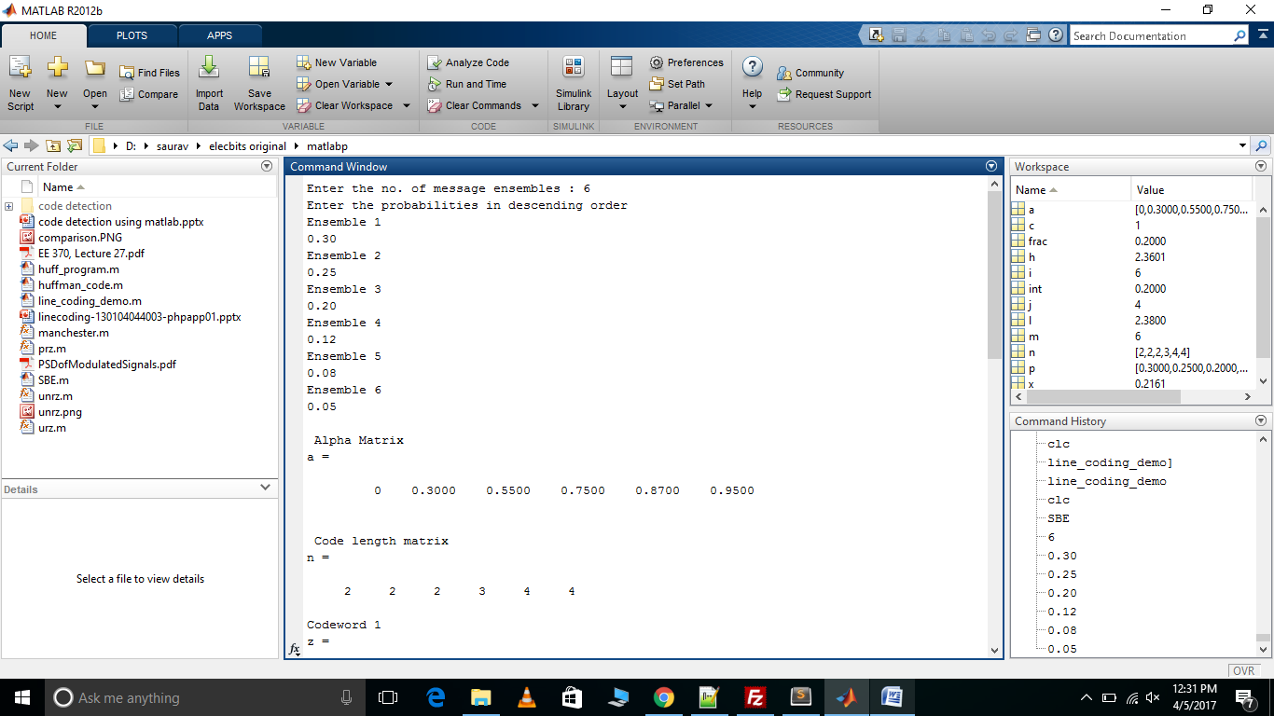

**Codewords -**

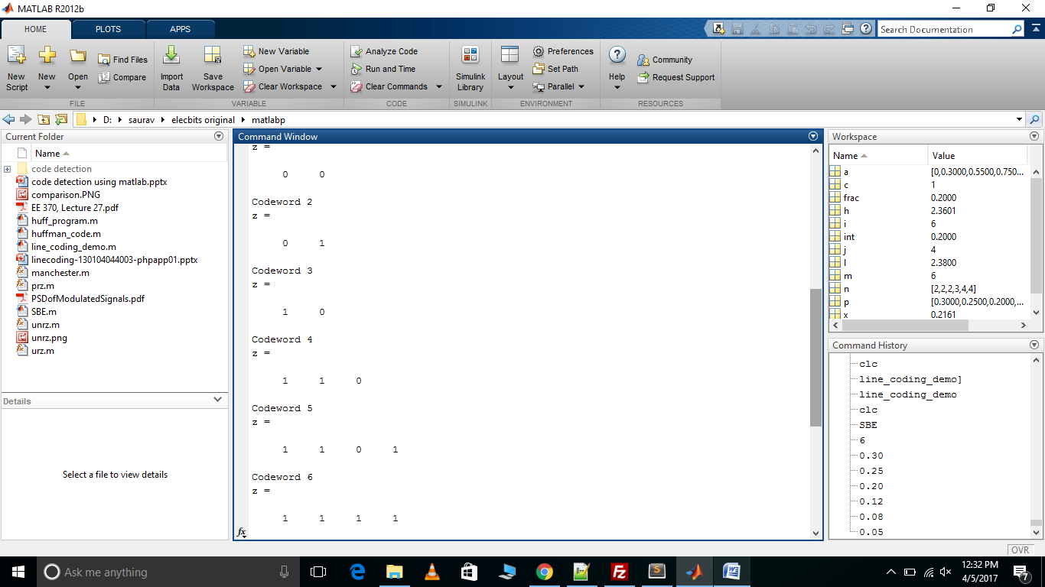

**Entropy, Efficiency, Redundancy and Average Code length**

